Indy R2000 Series Module Evaluation Kit

User Manual V1.1

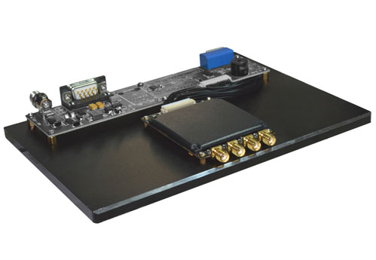

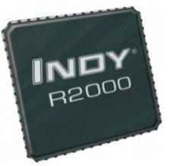

**Contents**

[1. About M-2800 Evaluation Board 3](#_Toc1094)

[1-1: Front View 3](#_Toc11154)

[1-2: Side View 3](#_Toc6068)

[2. Reader Configurations 4](#_Toc17711)

[2.1 Initial Use 4](#_Toc24395)

[2.1.1 Step 1: Powering the Reader 4](#_Toc186)

[2.1.2 Step 2: Connecting Antenna(s) to Reader 4](#_Toc1749)

[2.1.3 Step 3: Connecting Data Line to Reader 4](#_Toc18493)

[2.1.4 Step 4: Operating Reader via Demo 5](#_Toc4108)

[2.2 Setting RF Parameter 8](#_Toc16120)

[2.2.1 Setting RF Output Power 8](#_Toc24540)

[2.2.2 Setting RF Spectrum 8](#_Toc29226)

[2.2.3 Antenna Connection Detector 9](#_Toc8829)

[2.3 ISO-18000-6C tag inventory 9](#_Toc18752)

[2.3.1 Real Time Mode & Buffer Mode 9](#_Toc9592)

[2.3.3 Fast Switching Antenna to Inventory Tags 12](#_Toc30777)

[2.4 Accessing ISO-18000-6C Tag 13](#_Toc32484)

[2.4.1 Read tags 13](#_Toc3723)

[2.4.2 Write Tags 14](#_Toc21327)

[2.4.3 Lock Tags 14](#_Toc19914)

[2.4.4 Kill Tags 15](#_Toc22579)

[2.4.5 Tag Selection 15](#_Toc3802)

[2.4.6 Error Display Might Be Returned 16](#_Toc24304)

[2.5 Accessing & Inventorying ISO-18000-6B Tag 16](#_Toc29054)

[2.5.1 ISO-18000-6B Tag Inventory 16](#_Toc21653)

[2.5.2 Accessing to ISO-18000-6B Tag 17](#_Toc12664)

[2.6 Other Settings 18](#_Toc17672)

[2.6.1 Set DRM Status 18](#_Toc5532)

[2.6.2 Operating Temperature Monitoring 19](#_Toc9287)

[2.6.3 Set GPIO Level 19](#_Toc20608)

[2.6.4 Setting Buzzer Status 20](#_Toc30424)

[2.6.5 Charging The Serial Communication Baud Rate 20](#_Toc10164)

[3. Develop your own RFID Application 21](#_Toc31401)

1. About M-2800 Evaluation Board



1-1: Front View

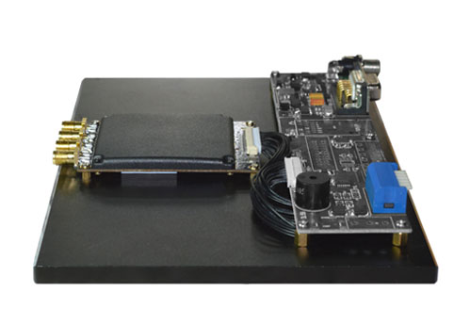

1-2: Side View

2. Reader Configurations

2.1 Initial Use

2.1.1 Step 1: Powering the Reader

Plug the **power cable** in, with the **indicator light** on and sound of a short **beep**, reader is ready. As illustrated below:

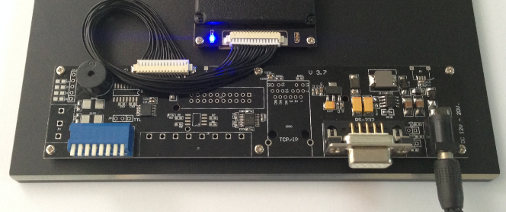

2.1.2 Step 2: Connecting Antenna(s) to Reader

Connect the antenna(s) with the antenna port as illustrated below:

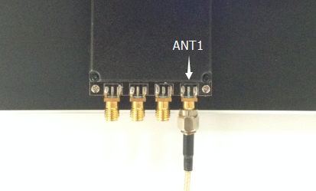

Access up to 4 antennas, as illustrated below:

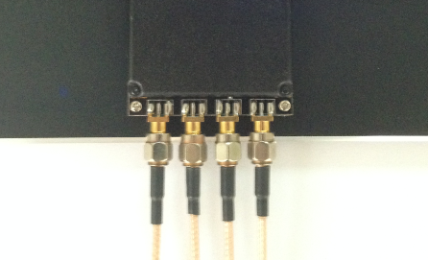

2.1.3 Step 3: Connecting Data Line to Reader

**Method NO.1:** You can connect the reader to your PC via RS-232 serial port, as illustrated below:

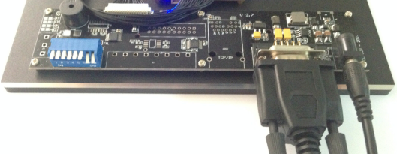

Next, please switch the DIP to the position as illustrated below:

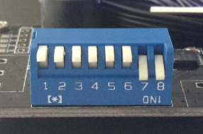

**Method NO.2:** You can also connect the reader to your PC via TCP/IP, as illustrated below:

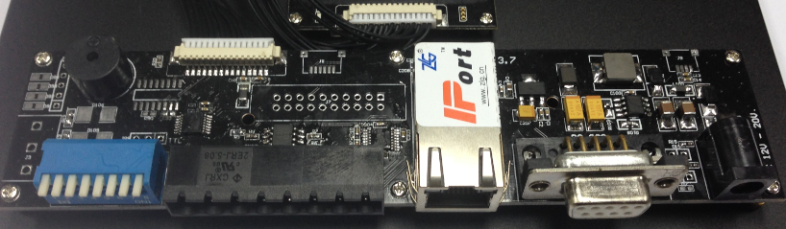

Next, please switch the DIP to the position as illustrated below:

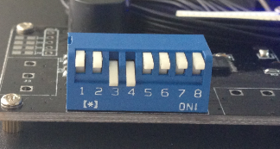

**DIP Switch：**

①：EN, ON Status, EN is low level.

②：GPIO1, ON Status, GPIO1 is low level.

③④：TCP/IP, ON Status is TCP/IP communication.

⑤⑥：Blank.

⑦⑧：RS232, ON Status is RS232 communication.

2.1.4 Step 4: Operating Reader via Demo

Put the **UHFDemo.exe**, **reader.dll**, **customControl.dll** into the same folder, and double-click **UHFDemo.exe** to run the software.

1. Open the software and it will shows as below:

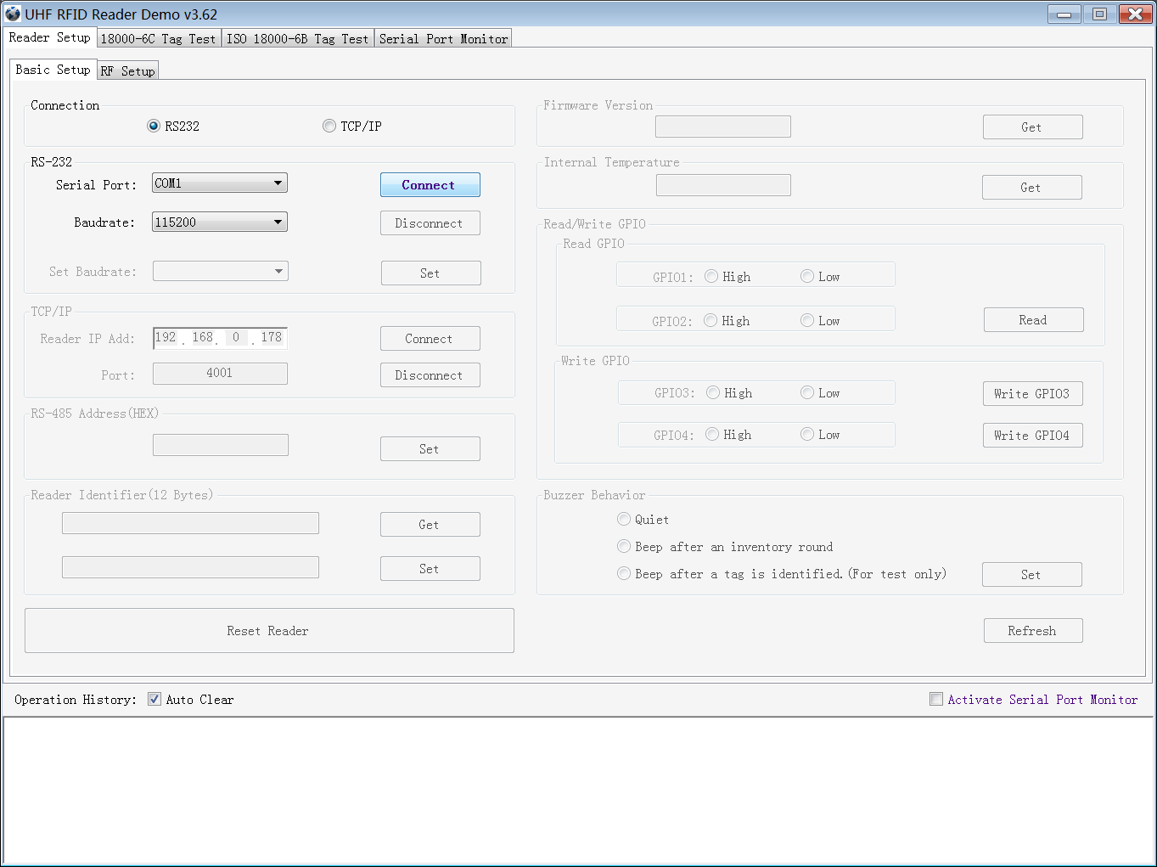

2. Please select **RS232** as **Connection** if the reader is connected via RS -232 port, Choose the corresponding **Serial Port** and **Baudrate** (default baudrate is 115200). As illustrated below:

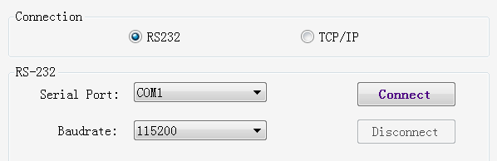

3. Click **Connect** , if it succeeds, the **Operation History** will display as below:

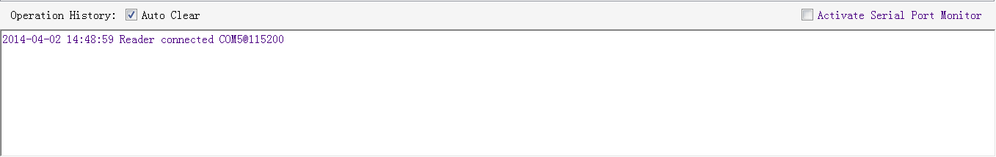

**If the reader is connected via TCP/IP, please follow those steps:**

* Ensure that an Ethernet Card has been installed in the PC.
* Ensure that PC and reader in the same network segment.

1. Default settings when connected via TCP/IP as follows:

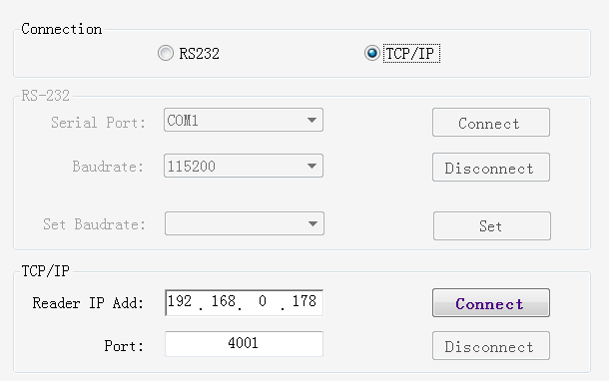

* IP addresses: 192.168.0.178
* Net mask: 255.255.255.0
* Port No.: 4001

For more TCP/IP configuration details, please defer to the document supplied:\ tcpip configuration \ IPORT-1UM.PDF

2. Click **Connect**, if it is connected successfully, the **Operation history** will display as below:

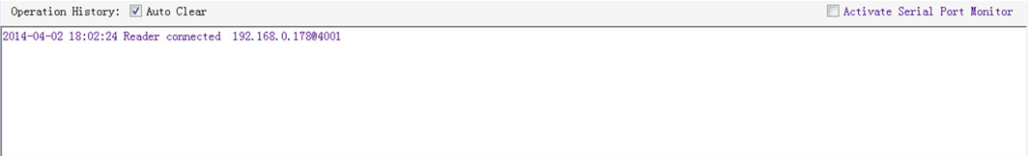

3. Text communication with the reader:

Click on **Get** in Firmware Version or in Reader Identifier, the following screen displays:

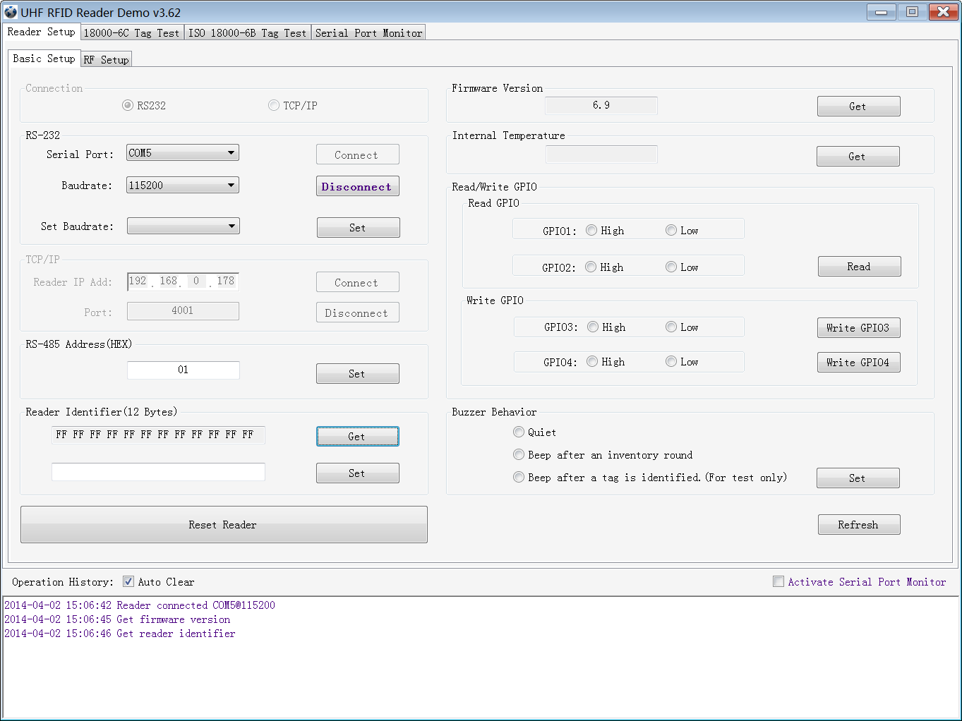

4. Now the reader has been connected to PC successfully.

2.2 Setting RF Parameter

After connecting the reader with PC, we need to set some basic RF parameters: RF Output Power & RF Spectrum. Please select **RF Setup** as illustrated below:

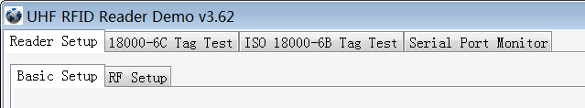

2.2.1 Setting RF Output Power

RF Output Power is the strength of RF output signal from antenna port whose unit is dBm.

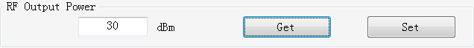

The output power range is 0 - 33dBm. When this setting completes, it will be saved in the reader automatically even if the power is cut off. Our default output power is 30dBm (1W).

2.2.2 Setting RF Spectrum

There are two methods to set RF spectrum.

**Method 1:** Use the default carrier frequency of the reader.

* Please defer to Frequency parameter tablet in Communication protocol for more information about the carrier frequency.
* Frequency range the reader supports: 865MHz-868MHz(ETSI), 902MHz -928MHz(FCC).

You can set the reader in **System Default Frequencies**, as illustrate below:

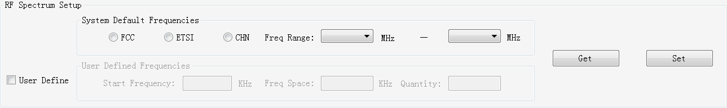

Notes:

* The start frequency and the end frequency must not exceed the scope of RF spectrum norm.
* Start frequency must be no more than end frequency.
* Set start frequency and end frequency to the same carrier frequency, the reader will work under fixed-frequency.
* When the parameter setting completes, RF carrier frequency of reader will be randomly hopping in the scope of limited range.
* The default RF spectrum norm is FCC (902MHz-928MHz).

**Method 2:** Set the RF spectrum manually.

Users can set RF spectrum via these three parameters: Start Frequency, Frequency Interval, The number of Frequency points.

2.2.3 Antenna Connection Detector

**Antenna Connection Detector** is for checking if the port is connected to the antenna before the reader work. Otherwise, users will be notified to connect the antenna. Please open this function before you use it, as illustrated bellow:



Sensitivity of Antenna Connection Detector is set by users which is the Return Loss of antenna port, the unit of which is dB. The larger this value is, the better impedance matching requirements between antenna and port. For normal antennas, you can set the threshold to 3-6dB. Sensitivity of Ceramic Antenna and Handset could be more lower.

Notes:

* Reader detects antenna connection by measuring the Return Loss of RF ports.
* Reader stops tag operation if Return Loss is above the threshold.
* User can turn it off by setting the threshold to 0.

If antenna is not connected, Reader will stop to operate tags with the following screen display:

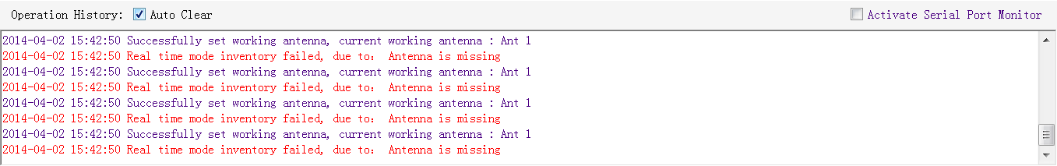

2.3 ISO-18000-6C tag inventory

Connect the Reader correctly. Tag operation could be started when RF Setup is completed.

**Tag inventory** means reader identifying multiple tags’ EPC number at the same time. This is the core function of UHF RFID Reader and one of the standards to judge a reader’s performance.

2.3.1 Real Time Mode & Buffer Mode

The most commonly used mode for tag inventory is **Real-time Mode**. Data will be uploaded meanwhile you can find the tags’ EPC number instantly. **RSSI** and **Parameter of Frequency** are changed and recorded in real time. Due to its dual CPU architecture, performance of multi-tag identification under **Real-time** mode is the best.

The other is **Buffer Mode**, the data will be cached and uploaded together when you need them. When there are tags with small volume, the data is uploaded filtered and with no repeat. But it will take some time to filter duplicate data when reader identifies a large number of tags. Therefore, its identification efficiency will be slightly lower than real-time mode. Note: Tags can’t be operated when you extract data in the cache.

Users can choose the appropriate method based on actual situation as illustrated below:

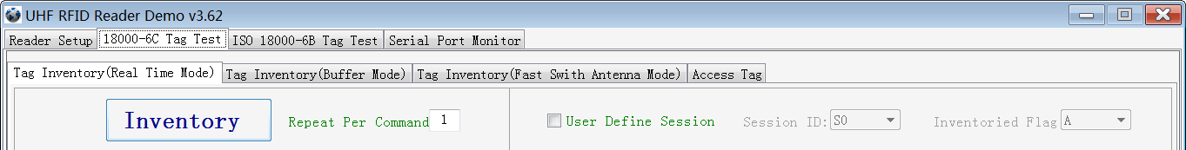

**Method NO.1: Real-time Mode**

1. Click **Tag Inventory (Real Time Mode)**. Select the connected antenna(s) port. Set the number of **Repeat Per Command**, which is the times of repeat inventory command. For example, inventory command will execute anti-collision algorithm one time when you set the value to 1. It will execute anti-collision algorithm two times when you set the value to 2...

2. Click **Inventory**, you will find that the EPC number is uploaded immediately and it is real-time updating. The reader will keep inventory until you click **Stop** as shown below:

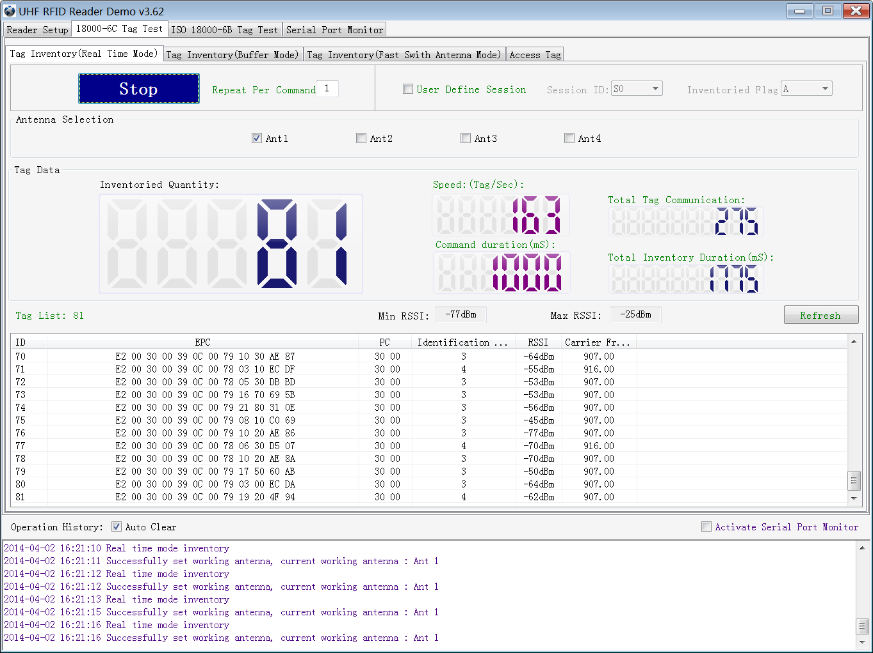

|  |  |
| --- | --- |
| Inventoried Quantity | Total number of inventory tags since click on **Inventory Tag**. |
| Speed | Speed of identification Tag, unit: piece / sec |
| Total Tag Communication | Total return EPC data of tags (Including repeated data) |
| Command Duration | Time of each Inventory Command takes, unit: ms |
| Total Inventory Duration | Total elapsed time since click on **Inventory Tag**, unit: ms. |
| ID | The serial number of data. |
| EPC | EPC number of tag. |
| PC | Protocol Control word of tag. |
| Identification Count | Times of tag identified. |
| RSSI | The signal strength when tag was identified at the last time. |
| Carrier Frequency | Carrier Frequency of tag which is identified at the last time. |

**Method NO.2: Buffer Mode**

1. Click **Inventory**, the screen will display as below:

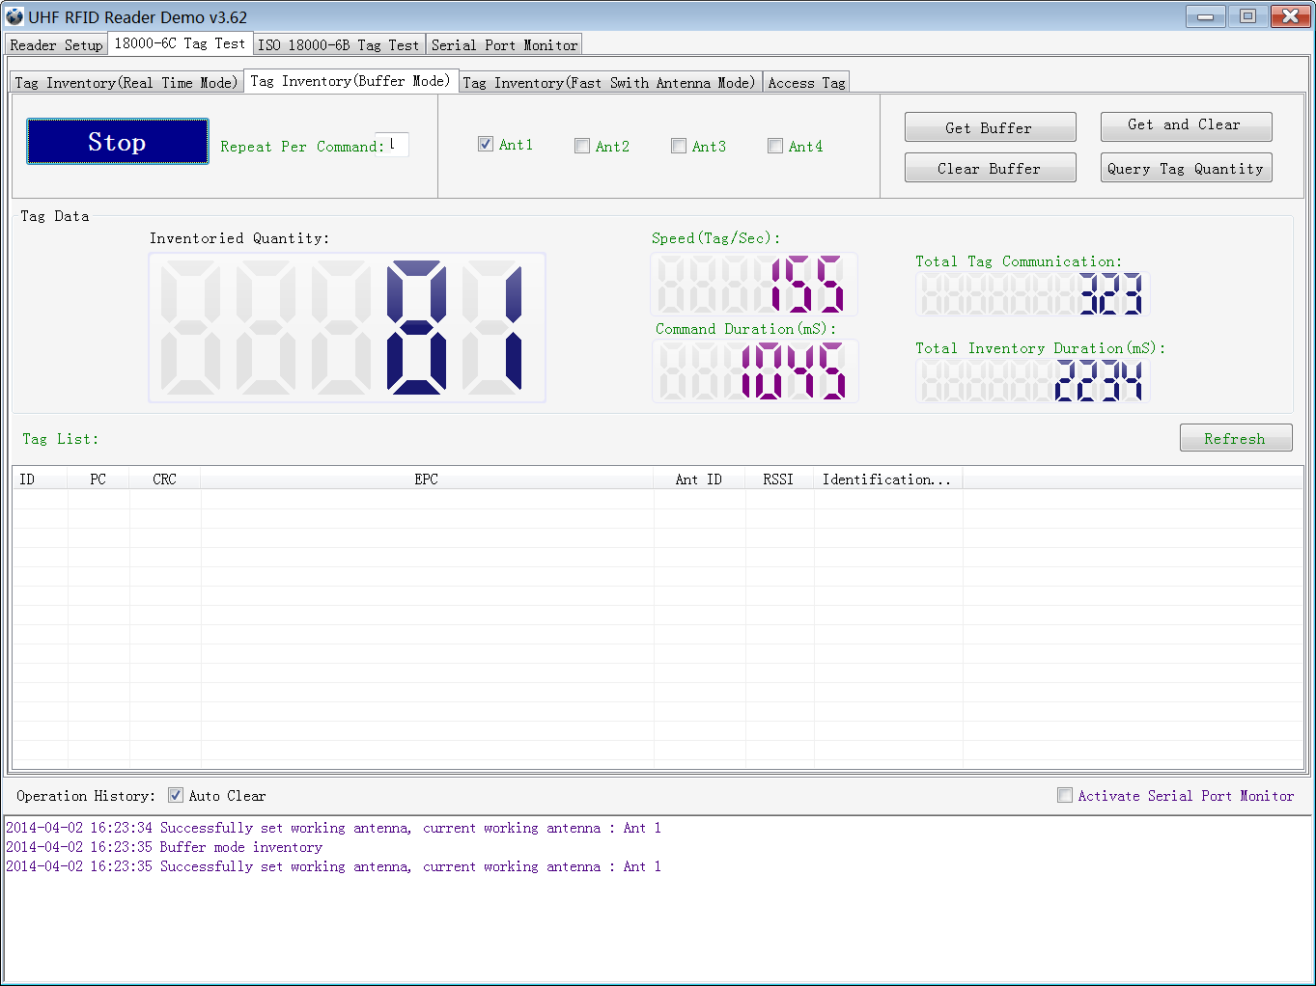

Note: the identified tags won’t be shown in the **Tag list**.

2. Click **Stop** first, then click **Get Buffer**. All the data in cache will be uploaded as illustrated below:

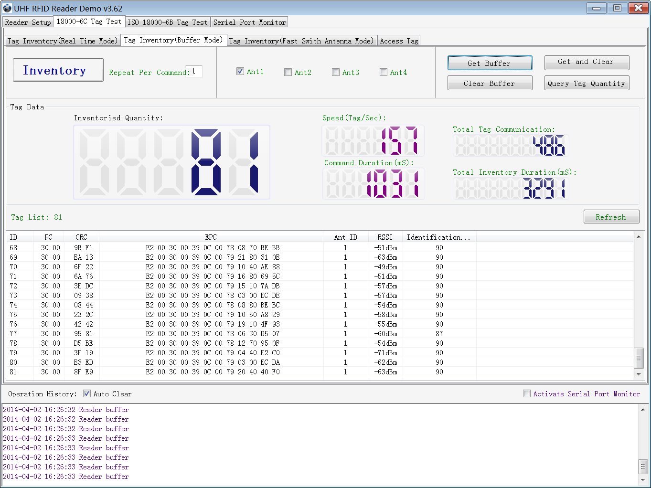

Functions description under Buffer Mode:

**Get and Clear:** Read the data form cache and then clear the cache. It will be empty when you read the cache again.

**Query tag Quantity:** If you just want to know there are how many tags in cache without details, click on this button.

**Clear Buffer:** Clear the cache and refresh the screen.

2.3.2 Users define Session ID & Inventorying Parameter of Inventoried Flag

2.3.3 Fast Switching Antenna to Inventory Tags

Under standard operation of tag inventory(Real Time Mode & Buffer Mode), the inventory period will takes at least 500-800ms. Only when inventory is completed, reader can respond to the other new command. Sometimes when 500-800ms is not accepted, we need to use Fast Switch Antenna function.

There are two methods to achieve fast switching antenna.

**Method NO.1:** Set the value of Repeat Per Command to 255 (0xFF), as illustrated below:

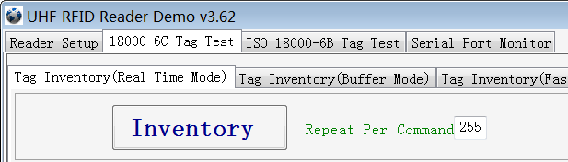

Click **Inventory**, operating time of each round will be as short as possible; Generally speaking, if there are only 1 or 2 tags in RF region, it will takes 50ms to finish the inventory before the reader receive new command. The time-consuming will longer with the increasing tags.

Note: For specific format of command parameter, please defer to the **UHF RFID Reader Serial Interface Protocol V3.1**.

**Method NO.2:** Use **cmd\_name\_fast\_switch\_ant\_inventory** command (see **UHF RFID Reader Serial Interface Protocol V3.1**).

Difference between method NO.1 and NO.2 is: the process of sending switch antenna command is omitted in method 2, so it is faster and more efficient, which takes 25ms to read one tag from one antenna.

Select **Fast switch Antenna Mode**, the following screen displays:

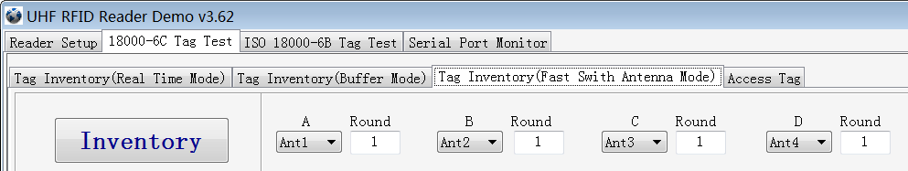

2.4 Accessing ISO-18000-6C Tag

Click **Access Tag**, and the screen will display as following:

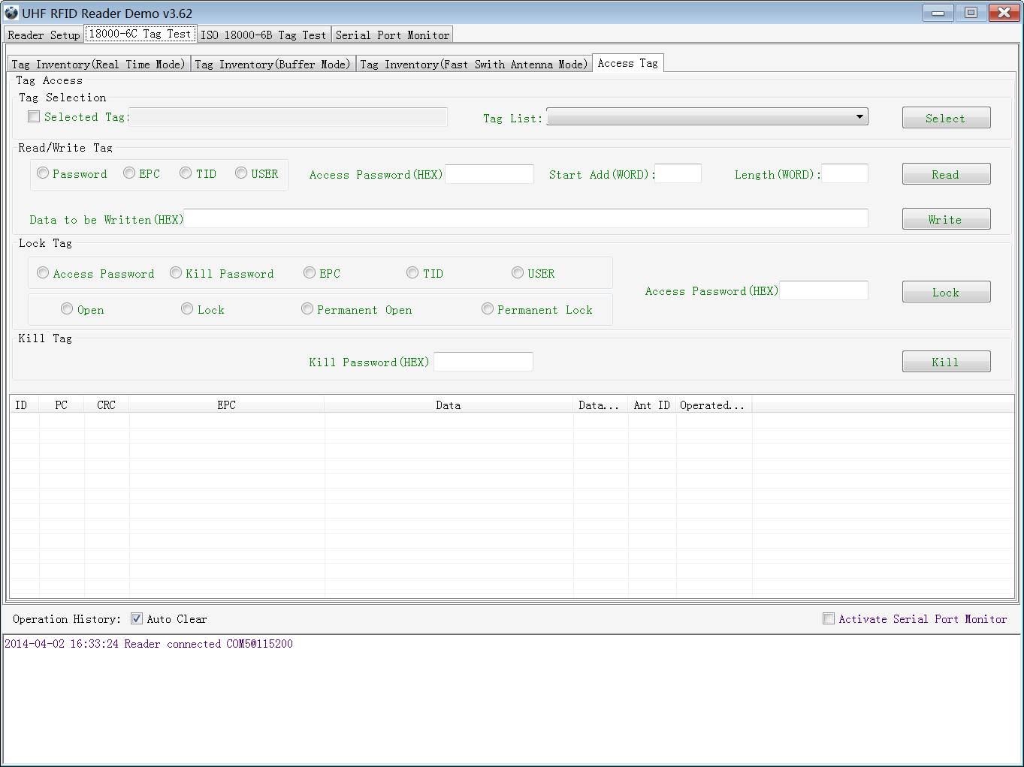

2.4.1 Read tags

You can type the parameter (zones to be read, Start Address and Data Length) as illustrated below:



Note: the unit of Starting Address and Data Length is WORD which is 16 bit double-byte.

Click **Read** when the parameter setting is completed.

Picture as below shows two tags have been identified successfully.

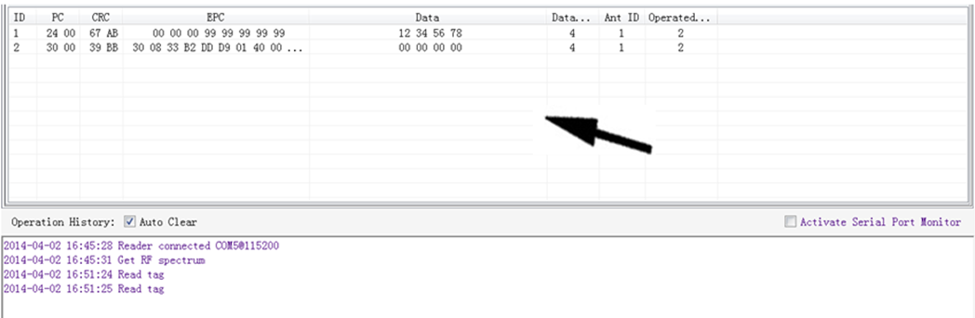

2.4.2 Write Tags

The area of Write Tag is the same as Read Tag, but you need to provide access password and information of write data.



When the operation done successfully, the screen will display as follows:

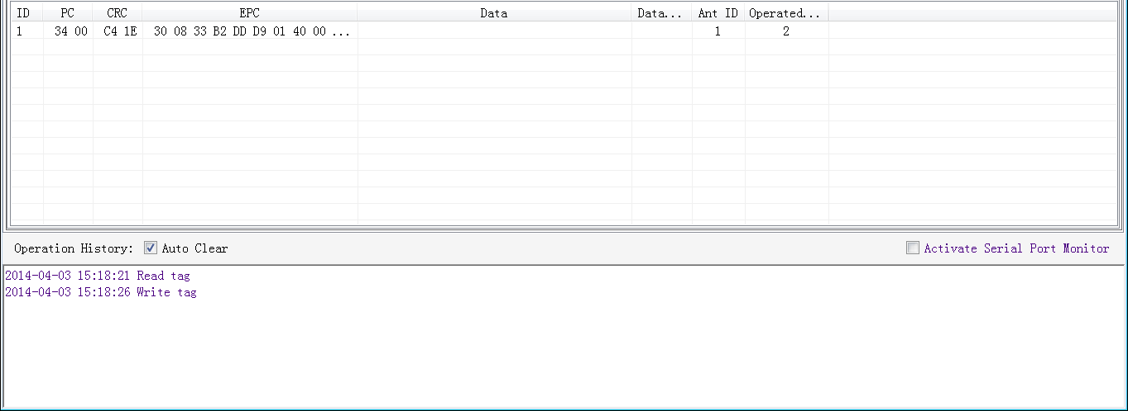

Note: The maximum length of one-time write is 32 Word (64 bytes, 512bits).

2.4.3 Lock Tags



A password is necessary to be provided for locking tags. When the operation is completed successfully, the screen will display as follows:

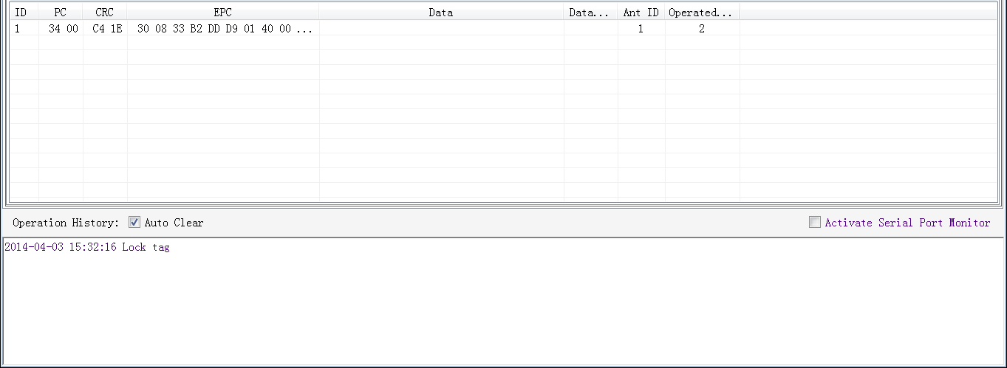

Same as **Write Tags,** data of identified tags will be displayed in **Tag List.**

2.4.4 Kill Tags



Password is necessary which can’t be 00 00 00 00 before Kill Tags. Therefore, to kill a tag please change the content of password via **Write Tag Operation** first.

When tag is killed successfully, the information will display as follows:

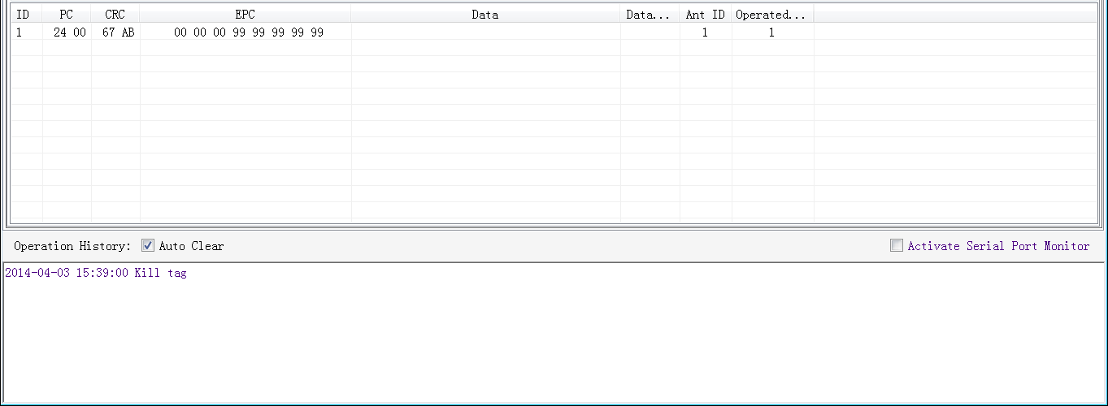

2.4.5 Tag Selection

No matter how many tags in RF region, we just want to access EPC tags which are already identified. Now, we can use the function of Tag Selection (EPC matching).

1. Inventory Tags in **Buffer Mode** to get all tags’ EPC number.

2. Get tags in cache.

3. Access tags and choose the EPC NO. which is needed , as illustrated below:

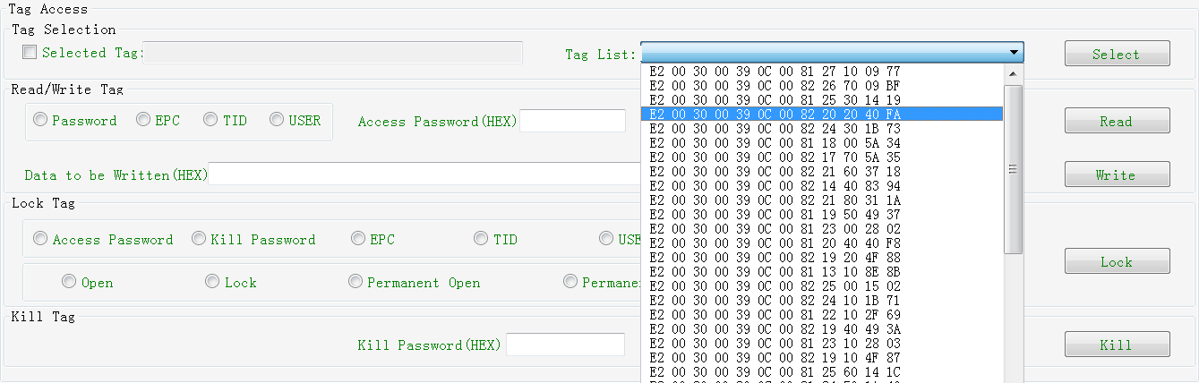

After choosing the tag, please click **Select** and the screen will display as follows:



We could see that the column on the left for **Selected Tag** has been selected. Next, all the operations are based on the tag with this EPC NO.

If you want to cancel the match of EPC, just deselect the column for **Selected Tag**, as below:



2.4.6 Error Display Might Be Returned

Errors occur if wrong operations done:

◆ Inventory success, access failure:

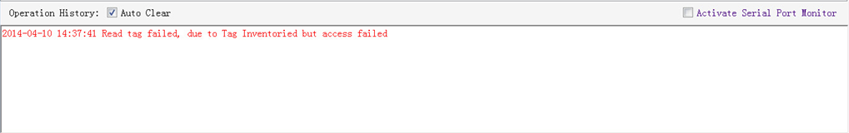

There are two steps to get access to tags: firstly, tag inventory; secondly, access tags. Picture above shows the inventory is successful, but we can’t access to tags.

Two reasons why:

1. Parameters incorrect: for example, zones(password/ EPC/ TID/ User) to be read do not exist.
2. Tags beyond the area that the RF could cover: distance when accessing to tags is about 60%-70% of tag inventory; in this case, please proceed the tag closer to antenna.

◆ Wrong password:

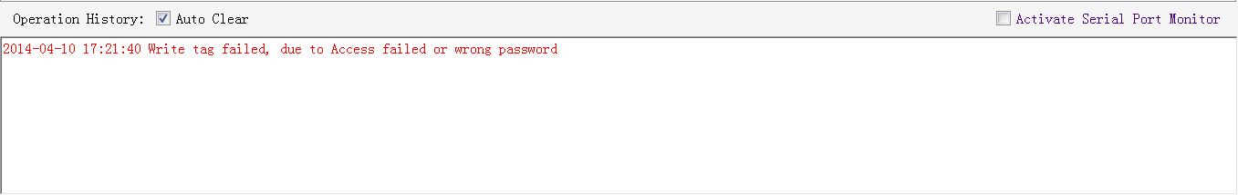

Reason why: wrong password is set.

◆ No tags to be operated：

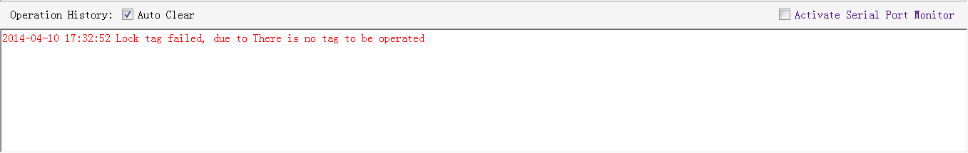

Reason why: Tags beyond the area that the RF could cover.

For more information about the operation history returned, please defer to the document: **UHF RFID Reader Serial Interface Protocol V3.1.**

2.5 Accessing & Inventorying ISO-18000-6B Tag

2.5.1 ISO-18000-6B Tag Inventory

Operating ISO-18000-6B Tag is similar to ISO-18000-6C but it will be easier, since **Real-time** is the only mode for ISO-18000-6B tags inventory, as illustrated below:

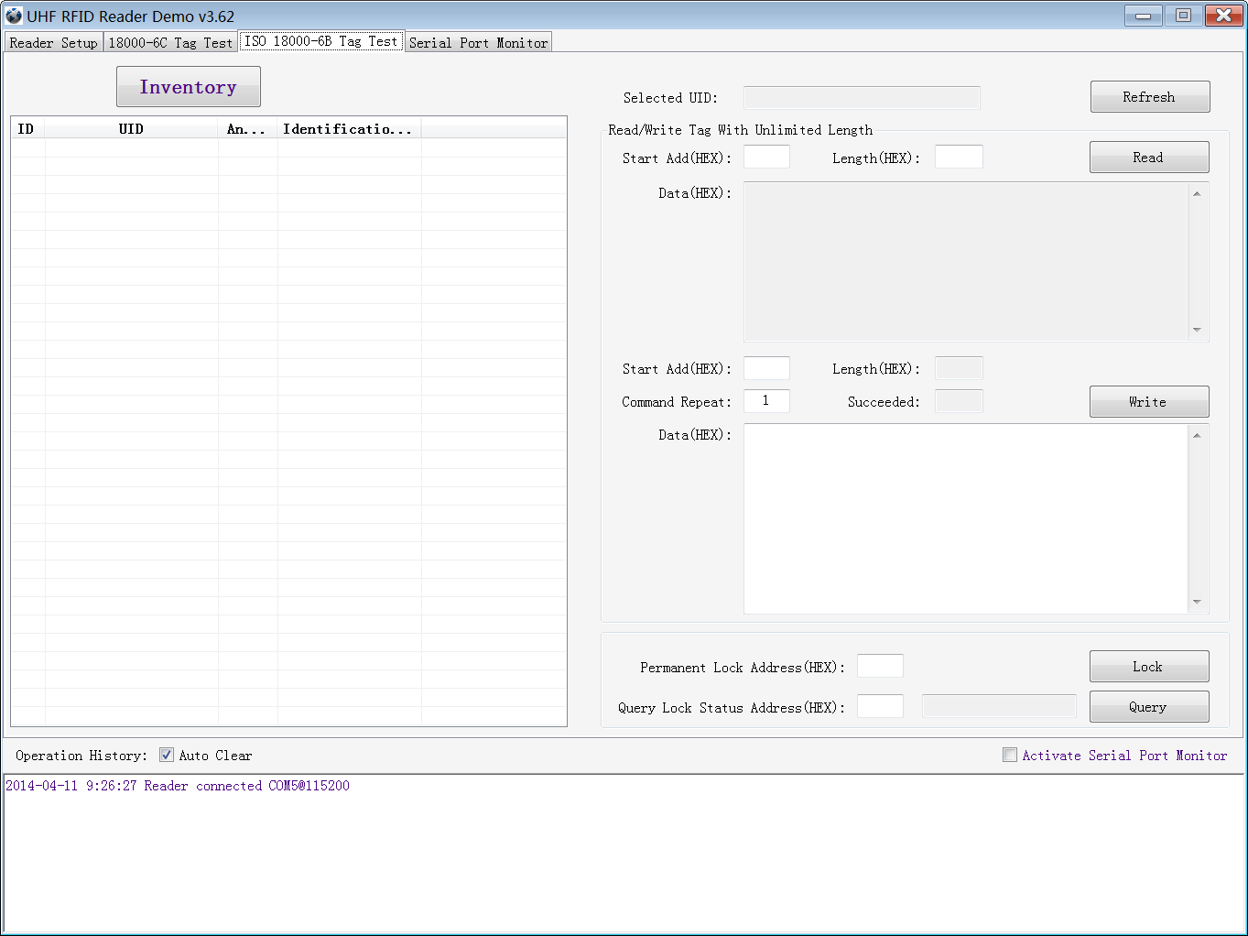

Each time when the reader identifies a tag’s UID, the buzzer will sound with a short beep. If the buzzer sounds with a long beep, it means the reader start the anti-collision function and identifies multiple tags at the same time.

2.5.2 Accessing to ISO-18000-6B Tag

There is only one tag available each time when we get access to ISO-18000-6B tag. After stopping inventory, please click the Tag UID on the left list to choose the tag you would like to do the operation, as illustrated below:

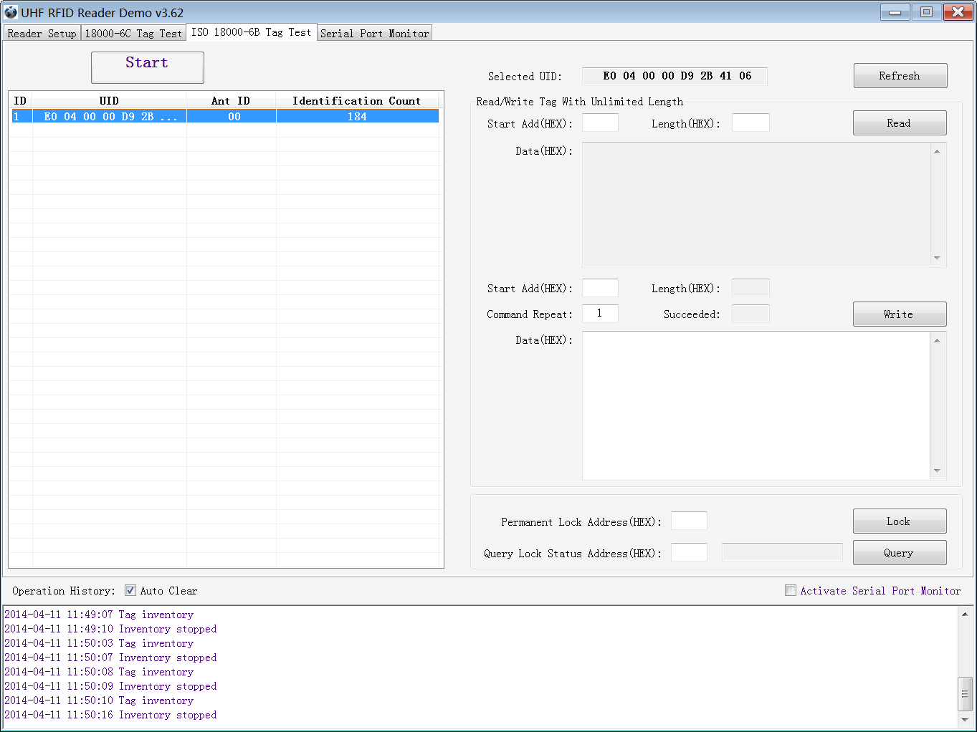

Notes for access operations:

◆Access operations only for the selected tag.

◆It can read multi-byte data of tag at the same time, length of the data is not limited.

◆Multi-byte data could be written. If error occurs, the reader will stop writing, but data which has been written will not change, thus reader will return the number of bytes which have been written successfully.

◆Only one-byte data of tag can be locked each time.

◆Only one-byte data state of tag is queriable each time.

◆Operation to lock tag is permanent and irreversible.

* 1. Other Settings

2.6.1 Operating Temperature Monitoring

Reader will generate heat under intensive work. Users can monitor the internal temperature via built-in temperature sensor to avoid reader overheating (Operating temperature over 65℃). **Temperature Monitor** illustrated as below:



2.6.2 Set GPIO Level

General-purpose input/output (GPIO) is a generic pin on an integrated circuit whose functions (including whether it is an input or output pin) can be controlled (programmed) by users. This reader provides two inputs (GPIO1 and GPIO2) and two outputs (GPIO3 and GPIO4).

The image of GPIO port as below:

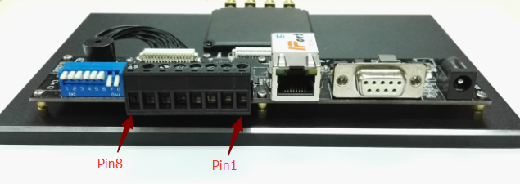

|  |  |  |  |
| --- | --- | --- | --- |
| **PIN ID** | **Function** | **Equivalent Circuit** | **Instructions** |
| PIN 1 | GPIO 1 Input + | C:\Users\Jon\AppData\Roaming\Tencent\Users\1292979819\QQ\WinTemp\RichOle\ZUQY]AH@0D3T3}I0}_@6MKT.png | ◆Voltage between PIN 1,2 (PIN 3,4) <=12V  ◆Hetero-polarity  ◆LED equivalent resistance 470Ω  ◆Response time<= 150uS |
| PIN 2 | GPIO 1 Input - |
| PIN 3 | GPIO 2 Input + |
| PIN 4 | GPIO 2 Input - |
| PIN 5 | GPIO 4 Output | AIJ`UQ((43YEFI`_(]IXN67 | ◆Voltage between PIN 5,6 (PIN 7,8)<=12V  ◆Non-polarity  ◆On resistance110Ω  ◆Response time <= 6mS |
| PIN 6 | GPIO 4 Output |
| PIN 7 | GPIO 3 Output |
| PIN 8 | GPIO 3 Output |

Operations as below:

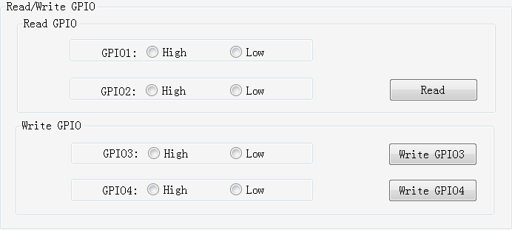

Users can use the serial port commander to read and write GPIO in their own applications.

2.6.4 Setting Buzzer Status

Reader’s working status is provided to users through the Buzzer. Three ways to set the buzzer:

1. **Quite**: turn off the buzzer
2. **Beep after an inventory round**: set it as beep each time when tag inventory is taken.
3. **Beep after a tag is identified**: set it as beep each time when reader identifies a tag. ( It will reduce the efficiency of multi-tag identification)

This setting will be stored even when the power is cut off.

Operation as below:

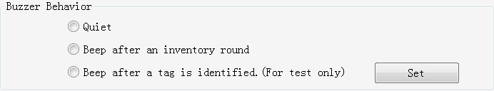

Note: There is a short beep when turn on the reader (reader self-test to check the connection to PC), which is not controlled by this setting.

2.6.5 Charging The Serial Communication Baud Rate

Reader supports two kinds of baud rate: 38400 bps and 115200 bps.

You can set baud rate as below:

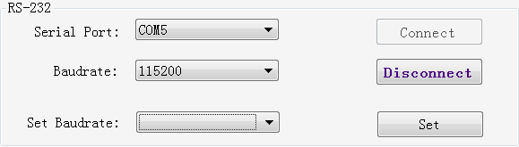

This setting will be stored even if the power is cut off.

Notes:

◆When connecting the reader with TCP/IP port, please change the serial rate of TCP/IP module correspondingly. For more details, please check the TCP/IP interface configuration document.

◆Tag inventory under **Real Time Model** will produce large amounts of data, please try to use 115200 baud rate.

3. Develop your own RFID Application

Most reader functions can be operated through the demo. But in practical applications, user might need to develop their own applications. Please defer to the document: **UHF RFID Reader Serial Interface Protocol V3.1.** The reader follows the definition both of the RS - 232 and TCP / IP interface.

Demo provides an important function of recording serial transmission, so that users can quickly grasp the content of communication protocol in practice. Please defer to the screenshot below and select **Activate Serial Port Monitor**, all uplink and downlink serial data will be recorded, as illustrated below:

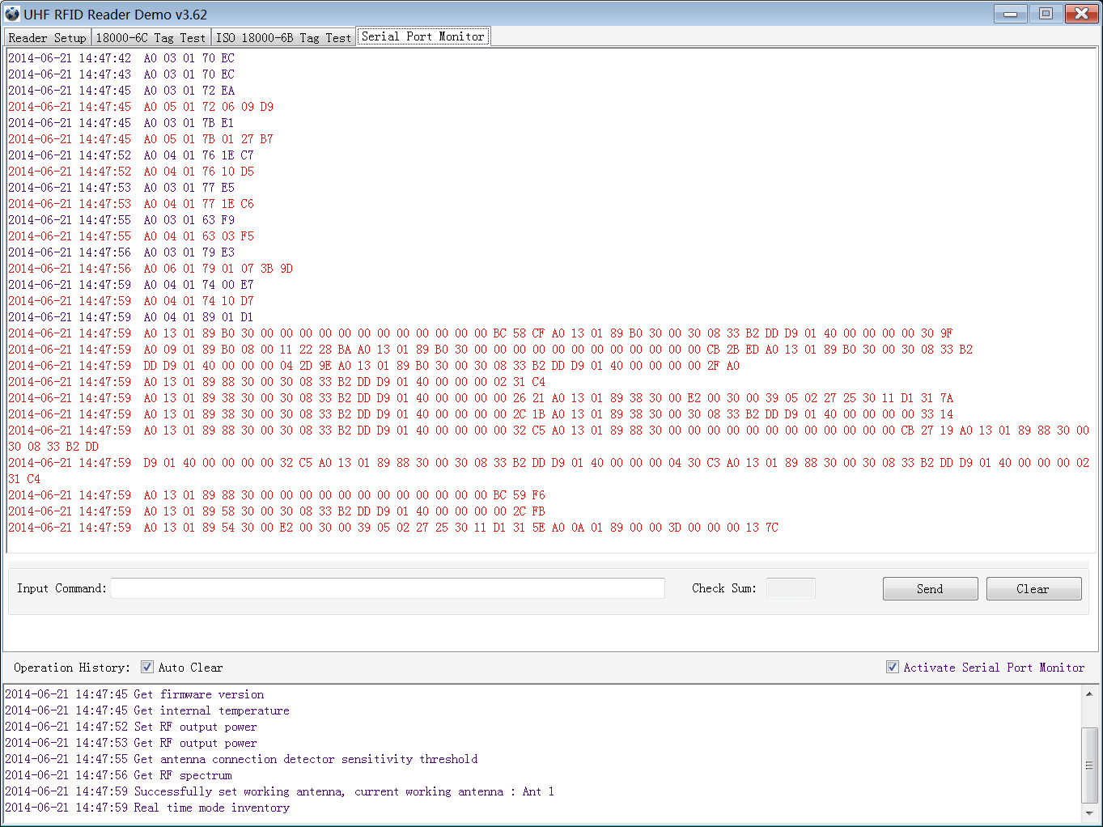

Notes:

1. Response speed of Demo will slow down after opening the **Activate Serial Port Monitor**. Please turn off this function when it is not necessary.

2. Data in violet blue is sent to the reader by PC, and data in red is the returned information to PC via reader.

3.Manual **Input Command** is used to debug serial command which could calculate the checksum automatically.

4. **UHF RFID Reader Serial Interface Protocol V3.1,** this document includes the integral source codes of the demo（Based on C # of .Net platform）to help users develop applications on the reader. Thank you!